Developing a sustainable Land-use indicators for Mediterranean cities: Case of Irbid city, Jordan

Hadeel T. Obeidat
Department of architecture, Faculty of Engineering, Al- Balqa' Applied University.
Email: Hadeel.Obeidat@bau.edu.jo, Irbid 22110, Jordan
Jaser K. Mahasneh
Department of architecture, Faculty of Architecture and Design, Jordan University of Science and Technology
Email: jkmahasneh@just.edu.jo, Irbid 22110, Jordan
Abstract
Demand for sustainable land use applications is increasing, due to poor urban planning practice in relation to land use, rapid urbanization, and unmanaged land uses. This paper aims to measure the extent of application of twenty-five urban sustainability indicators to land use planning, which was reached through the methodology of reviewing the latest findings of the literature. The authors then used the significance/satisfaction survey tools. The survey collected data from employees and engineers of government authorities, landowners, and dealers from the local public and their satisfaction with the level of application of these indicators. The survey implementation is described and the results are summarized. The results of the survey revealed a lack of perception and knowledge of the local public regarding the application of sustainability indicators in the city, in addition to a weakness in their application by government agencies in planning land use, which urged the authors to propose many proposals and future alternatives that will ensure the improvement of municipalities, services and the provision of adequate housing in a healthy urban environment.
Keywords: Sustainable development, Indicators, Assessment, Land use.

ملخص البحث
يتزايد الطلب على تطبيقات الاستخدام المستدام للأراضي ، بسبب سوء ممارسة التخطيط الحضري فيما يتعلق باستخدام الأراضي ، والتوسع الحضري السريع ، واستخدامات الأراضي غير المدارة. تهدف هذه الورقة إلى قياس مدى تطبيق خمسة وعشرين مؤشرًا للاستدامة الحضرية على تخطيط استخدام الأراضي ، والتي تم الوصول إليها من خلال منهجية مراجعة أحدث نتائج الأدبيات. ثم استخدم المؤلفون أدوات مسح الأهمية / الرضا. جمع المسح بيانات من موظفي ومهندسي الجهات الحكومية وملاك الأراضي والتجار من الجمهور المحلي ورضاهم عن مستوى تطبيق هذه المؤشرات. تم وصف تنفيذ المسح وتلخيص النتائج. كشفت نتائج المسح عن نقص في الإدراك والمعرفة لدى الجمهور المحلي فيما يتعلق بتطبيق مؤشرات الاستدامة في المدينة ، بالإضافة إلى ضعف في تطبيقها من قبل الجهات الحكومية في تخطيط استخدامات الأراضي ، مما حث المؤلفين على اقتراح العديد من المقترحات. والبدائل المستقبلية التي ستضمن تحسين البلديات والخدمات وتوفير السكن الملائم في بيئة حضرية صحية.
الكلمات المفتاحية: التنمية المستدامة ، المؤشرات ، التقييم ، استخدام الأراضي.

Introduction
The planning process is very important to mitigate the negative impacts of land use impacts and to encourage sustainable use of resources with minimal impact on future generations (Fawry, 2014). These reasons have prompted planners to introduce the concept of sustainability into their science in an effort to better understand the current and future needs of the population (Common Questions, 2014). When looking at sustainable development, land use planning is seen as the process of administrative, political and technical decision-making agreed with the political, social, economic and technical factors of sustainable land use. To ensure environmental protection during land laying or land use (Samara, 2015).
There have been many research attempts to prove the sustainability of land use and to reveal practical and scientific challenges through evaluation, but despite the existence of general sustainability standards and agreements for their implementation, there are very few studies that examine the application of these standards in land use on the ground.
Thus, studies on the sustainability of land use planning are necessary and important because they will help in searching for solutions and plans in presenting policies and proposals that will contribute to the urban planning process and help all cities understand the urban state of sustainability, benefit the development process in its various aspects, and achieve the desired goals more precisely and in Dealing with reality.

Literature review
In order to meet human needs now and in the future, Sustainable Land Use ensures a fair and equitable allocation of land, water, biodiversity, and other environmental resources among competing claims.(Koomen, 2021)
When looking at sustainable development, land use planning is act as the administrative, political and technical decision-making process agreed with political, social, economic and technical factors, for the sustainable use of land, and on the other hand, it seeks to promote and organize human sites and their sustainable development, even activities Social and economic, and spatial, physical growth had a share in this process, based on identifying constraints and capabilities that take into account social, economic, environmental, geopolitical, and cultural standards, and in order to ensure environmental protection During the land development or use of land is put these parameters (Metternicht, 2018).
The reason is that there is a need for sustainability to ensure that we continue to enjoy the life that comes to ensure the continuity of future generations and the ability of these generations to enjoy these benefits, is that the use of land refers to the choice of a specific region according to its agricultural capacity and thus its development potential, and is classified according to its location as rural or Urban, and represents an essential element for the development of the city and the upgrading of its residents because it is from these that the urban structure is formed and thus its function is determined (Ziadat et al., 2017).
Several methods of assessing urban sustainability through indicators have been developed in several studies, (O.O. Ugwu & Haupt, 2007) they analyzed the tools available to define and measure sustainability, so they used the 'Weighted Total Model' methodology in the Multi-Criterion Decision Analysis (MCDA). In AHP, the 'added benefit model' for multi-criteria decision-making and the creation of a sustainability index calculation model - a simple value for evaluating infrastructure design proposals. Then they discussed the development of KPIs that were included in the analytical model, and (Zhang et al., 2008). She suggested classifying the indicators according to the methodological foundations, which divided them into three groups: critical assessment, instrumentation engineering, and indicator-based biophysical evaluation.

There have been many research attempts to prove the sustainability of cities or their lack of sustainability, and to reveal practical and scientific challenges through evaluation, and among these researches were: (Briassoulis, 2001), (Roy, 2009), and (Tanguay et al, 2010). These studies indicate that indicators should be sound, basic, scientifically clear and verifiable, according to the United Nations Institute for Statistics for Asia and the Pacific (2007).
The lack of a systematic and evaluable definition of land sustainability metrics is often cited as a major drawback. However, as (Gallopín, 1995) has argued, the research framework for sustainability should be more varied than the traditional physics, chemistry or agricultural science research paradigm, making it more difficult to measure. Since it aims to test the likelihood of applying these indicators and criteria, rather than detailing various null hypotheses or the effects of some inputs or land management measures, such a research model should be built around an evaluation mechanism (and not within an objective context). The research form should mainly include a mission statement, conceptual structure, set of procedures, and diagnostic criteria (indicators). Is good research on the sustainability of developing cities, capacities, or a better representation of what is needed being hampered by the lack of a quantifiable concept and concrete sustainability goals? The non-quantitative meaning brings a variety of methodology, according to personal observations from different case studies. As a result, the SLM principle can be implemented at different levels and scales to address the various issues while providing clear guidance on the scientific criteria and procedures to be followed during the assessment.(Herrick, 2000)

Problem statement
Sustainable urban planning is employed for guiding urban development by making physical plans and development regulations. Moreover, its social, economic, environmental, and constructive efforts can make an urban area a better place to live in the future. However, there is a lack of Jordanian studies that focus on assessing sustainability in Jordanian cities in terms of planning, especially in the field of land use, or the existence of strategies that achieve this sustainability within the limited organizational plans, which makes this study a requirement for the advancement of this field.
This study will present the descriptive analysis of the level of satisfaction of decision-makers and a sample of the local public with the application of sustainability indicators, and translate them into tables, numbers and ratios, in order to assess sustainability on the ground. A clear picture of the city's land-use sustainability and its relationship to planning will be presented to highlight the challenges and opportunities facing the city. So that future researchers can use it for a better design.
Methodology
The survey tool was adopted from the field of knowledge (quality of service) (), (Mahasneh, 2017). Whereas, this concept is used by scholars and experts in determining the extent of client or expert satisfaction with the subject presented in the research survey. Basically, the research survey was distributed and distributed electronically (due to the current circumstances due to the spread of the Coronavirus) into two main categories, the first category being experts and includes Irbid municipality employees and specialists in land use, as well as the Ministry of Agriculture and the Land Directorate, as it is closely related to land use. The second category was the local audience, which is a fundamental pillar of the sustainability process.
54 questions on multiple indicators were asked in a pre-developed list of sustainability criteria for land use. Where the application of the most important indicators of urban sustainability for land use internationally approved in most countries, especially developing countries, was extracted and summarized, and the latest results of studies were obtained that dealt with the basic principles of how to design and conduct the survey and how to analyse its results.

The responses of experts in the sustainability industry are adopted as the main assessors of the level of sustainability of land use. The survey tool consists of 6 main sets of questions and a subset.
The secondary group of questions focused on obtaining demographic information about the respondent and the company he is currently working for. Demographic information includes the respondent's gender, age, experience, primary function, and geographic location of his current work.
The first group was for the economic dimension which had (6) questions. Where the questions were asked to the respondent to assess the extent of applying a set of indicators in relation to the economic aspect, as well as to assess the extent of his satisfaction with the ability of these indicators to apply sustainability to land uses. The 48 questions asked them to do the same for the other five groups in the same way. It evaluated the environmental, social, planning, government, and finally infrastructure aspects.
Number of participants: The number of participants was divided into (200) people who are experts, employees of the municipality of Irbid and specialists in land use, and (200) people from the local public, who were all in this survey from specialists in the field of land employers who can evaluate sustainability indicators regardless of Their position or backgrounds.
Sampling technique: According to the methodology used, the study used a studied (non-random) sample imposed according to the approved research methodology. The sample was chosen according to who is the partner in the process of sustainable use of the land. .
But it is also a random sample within the same population. In order to avoid searching for bias in the intention sample imposed by the methodology, the questionnaires were distributed in the Irbid municipality and the Land Directorate randomly to individuals with different specializations and educational and employment levels, and the polls were distributed among members of Parliament. The local community of merchants, investors, governments, and non-governmental job holders, as well as with different levels of sciences and disciplines, and this means that the research sample is a (intended - random) sample.
Participant rating scale: Likert scale was used; Participants then rated significance and satisfaction using one of the following expiration periods (very low, low, medium, high, and severe high). While analyzing the data, the classification was transformed so that 5 equals very high response, 4 equals high response, 3 equals average response, denotes that the indicator is applied in reality, 2 equals low response, and 1 equals very low response This indicates that the indicator has not been applied.
The stage of choosing the appropriate statistical method: The proposed study imposed the trend towards descriptive statistical analysis, which aims to define the extent of application of the indicator on the ground, from the data matrix, where the rows express the answers of the investigated from them, while the columns express the indicators (indicators of urban sustainability for land use), in order to reduce Simplifying data without favoring an indicator over others in the analysis.
Preparation of survey lists: Surveys lists were prepared to examine the extent of implementation of the indicator on the ground, and according to the list of preliminary indicators that were reviewed by the literature, two experts from the Irbid municipality and the Land Directorate were consulted to ensure the quality of the survey. After that, the survey was tested in an experimental administration, where a small number of research surveys were distributed to a small number of the sample, and to ensure that the questions were understood and clear, then the research survey mail was sent to each respondent and a follow-up was conducted for each one of them after a week. These led to (400) responses to the research survey, which is the number who completed the research survey.
Analyzing the lists of surveys and their results: The results of the surveys with regard to the first part of the general information showed the following: Regarding the academic achievement paragraph, the results of the surveys showed that there is a diversity in the specialization of the samples. In which the lists were distributed, and according to the proportions shown in the figure.

Figure (1): The educational level of the sample

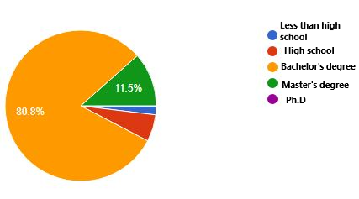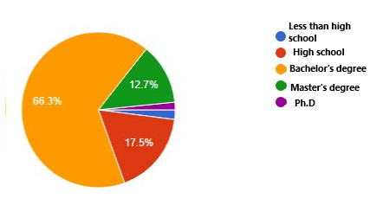

Experts
The local audience

Figure (2): The location or workplace clause of the experts sample
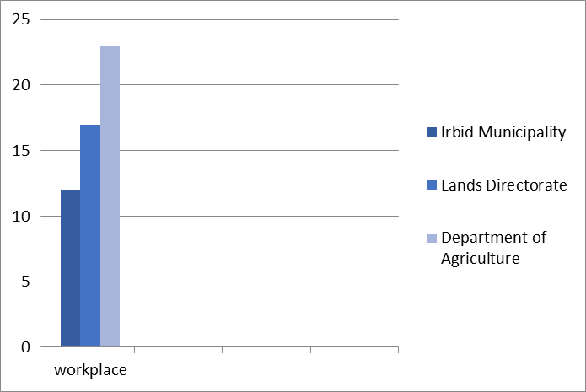

Figure (3): The location or workplace clause of the local audience sample

The results shown in the above show clearly that the sample to which the survey lists were distributed completely deviates from bias, as if they were deliberately directed towards what the research methodology imposed from societies, however, the lists were distributed, and as the research previously showed, on different samples , And randomness, within those societies, as they, according to the illustrative figures above, differ in academic achievement, scientific and academic specialization, work sites, and years of service, and significantly, and have supported the results illustrated through the illustrative forms, since the sample came (randomly) within the community ( Which was chosen), according to the research methodology (intentionally), and this means that these results confirm what the research went to, that the sample is of the complex type (intentional-random).
As for the last question in the first part of the survey, which is the extent of the surveyed among them about the movement of urban sustainability and its applications in the countries of the world, the percentages were as follows:

Figure (4): Knowledge of the sample about the urban sustainability movement and its applications in the countries of the world
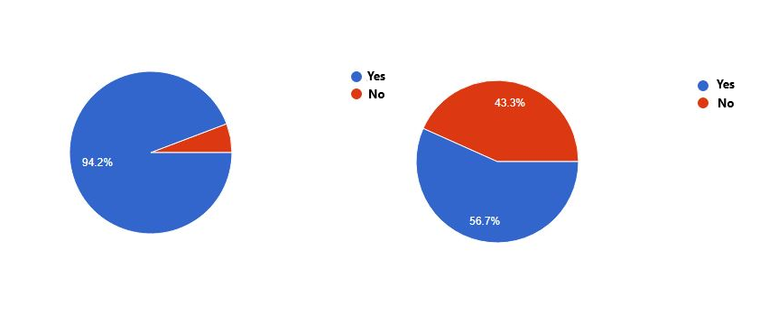

Experts
The local audience

Evaluation results for preliminary indicators for the first dimension (the economic dimension)

(Table 1) shows the percentages of evaluation by experts and the local public on the application of sustainability indicators in the economic dimension from one to five. Therefore, when evaluating the first indicator (the initial cost of land), we find a percentage (42.3%). The experts agreed that the initial cost of the land is very high, but compared to the local public’s evaluation of the same indicator, we find that their answers were limited to the high cost, but with varying proportions between the average height and the very high. . . This applies to the rest of the indicators (the cost of land during the life cycle, the cost of resettlement for people, the ratio of low and medium-cost land to high-cost homes), but in the end we found that experts and the local public are in agreement on the value of the rise and thus the failure to achieve this sustainability indicator.
See (Table 1)

But when you look at the results of evaluating the indicator (rehabilitating the cost of the ecosystem), we find that the experts and the local public have agreed on the low cost of rehabilitating the ecosystem, and the low cost, in this case, means the failure of the index to achieve sustainability.

Finally, the only indicator that achieved sustainability was the consensus of experts and the local public (land use controls the types of income), as their answers were limited to that this indicator is applied, but in proportions varying between moderately applied and strongly applied.

Table 1: Evaluating experts and Local audience ' answers about the sustainability of land use through the economic dimension

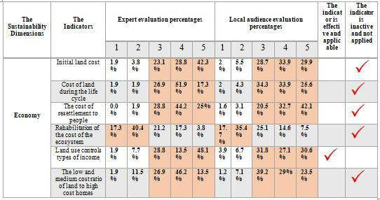

Evaluation results for preliminary indicators for the second dimension (the environmental dimension)

When reviewing the results of the assessment of land use sustainability indicators in the environmental dimension (Table 2), we find that four of the fifteen indicators have achieved sustainability according to the assessment of experts and the local public, who unanimously agreed to achieve sustainability (Table 2). In the percentage of habitats or feeding areas, the rate of agricultural land use and the annual increase in the type of forests, but we find that the experts agreed on the increase in environmental health in air quality, contrary to the opinion of the local public, which agreed that environmental health in air quality is very low. Here, the expert opinion is adopted for what is knowledgeable, knowledgeable and studying the topic in a purely scientific manner.

Table 2: Evaluating experts and Local audience ' answers about the sustainability of land use through the environmental dimension
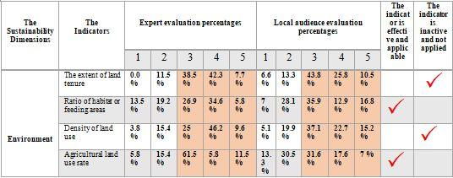
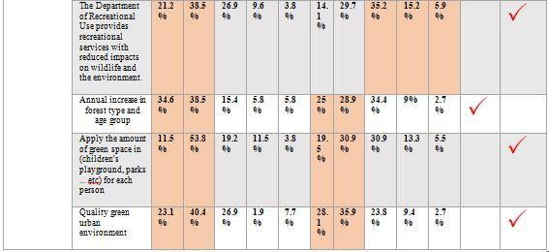

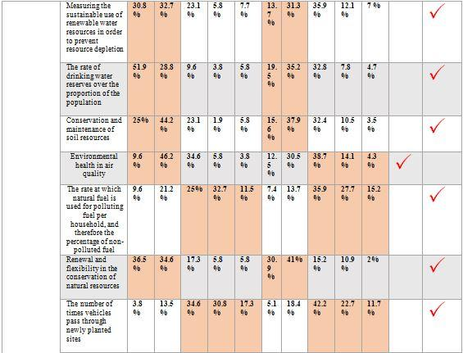

Evaluation results for preliminary indicators for the third dimension (the social dimension)

When reviewing the results of the evaluation of land use sustainability indicators in the social dimension, see (Table 9), we find that five out of thirteen indicators achieved sustainability according to the assessment of experts and the local public, who unanimously agreed on the high percentage of literacy learners from high school diplomas and from college to bachelor's degrees. The high level of public health among the citizens, the increase in the percentage of the population who have health insurance and the citizens' ability to afford housing costs, and the decrease in the percentage of the population who do not have shelter.

However, their opinions on the rate of documented crime were different relative to the overall percentage of the population. The high rate of recorded crime was decided by the experts, and the local population overwhelmingly agreed on the lower rate of recorded crime, and as the experts' opinion was eventually accepted earlier, see (Table 3).
Table 3: Evaluating experts and Local audience ' answers about the sustainability of land use through the social dimension
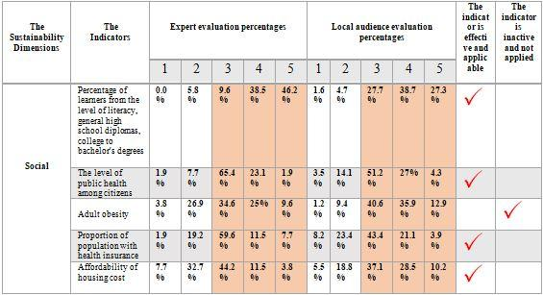

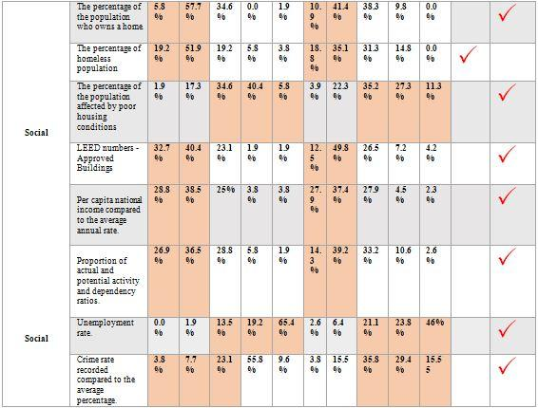

Evaluation results for preliminary indicators for the fourth dimension (the Governance dimension)

In the government dimension, we find that the results of the indicators evaluation tended to be fair in application, see (Table 4), so we find that two out of the four indicators achieved sustainability according to the assessment of experts and the local public, who unanimously agreed that the national policy and legal framework is applied strongly in the Jordanian government, and that the rate of compliance with legal requirements is very high, but it lacks the extent of its participation and transparency with the citizens, see (Table 4).

Table 4: Evaluating experts and Local audience ' answers about the sustainability of land use through the governance dimension

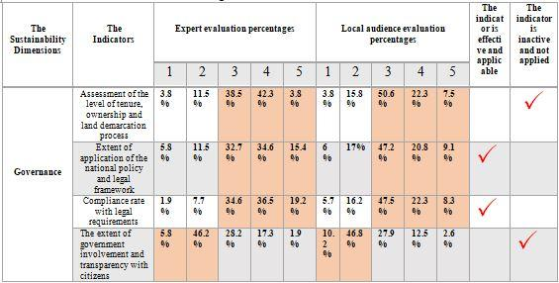

Evaluation results for preliminary indicators for the fifth dimension (the Planning dimension)

In the planning dimension, we also find that the results of the indicators evaluation tended to be fair in application, so we find that two out of four indicators achieved sustainability according to the assessment of experts and the local public, who unanimously agreed that there are environmental legislations that are strongly applied, and the level of implementation of compatible land uses is high and severely, but it is lacking to the existence of rural planning for the city villages.

Table 5: Evaluating experts and Local audience ' answers about the sustainability of land use through the planning dimension
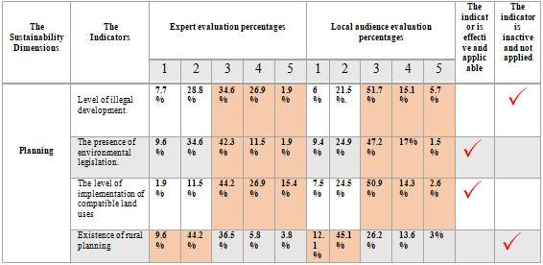

Evaluation results for preliminary indicators for the sixth dimension (the Infrastructures dimension)

Finally, in the infrastructure dimension, we find that the number of indicators that achieved sustainability in land use exceeded the number of indicators that did not achieve sustainability, see (Table 6). The results of the indicators evaluation demonstrated ease of access to main roads, ease of operation of buses, ease of access to communications and postal services. However, the high rate of road density and the high average distance between current lands uses prevented all indicators of land use infrastructure dimensions from being implemented, see (Table 6).

Table 6: Evaluating experts and Local audience ' answers about the sustainability of land use through the Infrastructures dimension

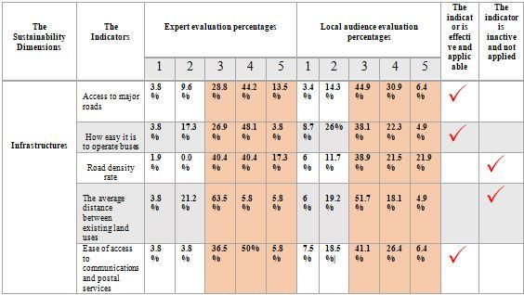

We conclude here that the priority in the dimensions of the sustainability of advanced land uses towards enabling sustainability in the city of Irbid is the infrastructure dimension, where the percentage of achieving sustainability with its indicators has been applied by more than 50%, meaning that the infrastructure dimension related to the efficiency of services provided for land uses was high, which is mainly related to The extent to which the environment of land use is preserved, and this is what plays an important role in designing a development strategy that will enable or pave the way for sustainability in this city, as this study will show later.

As for the second dimension according to the priority order, it was for the (governmental and planning) dimension, where the percentage of achieving sustainability with its indicators was applied at 50%, followed by the social dimension, then the environmental dimension. As for the dimension of its sustainability indicators, only one out of six indicators, i.e. 16.4%, was applied to the economic dimension, which results in many issues that will be discussed later.

By reviewing the evaluation results of the indicators of sustainability for land use and presenting the process of integrating the opinion of the two parties of sustainable development with the opinion of the research, a set of actual indicators that achieve sustainability in the city was reached, see Table 7.
Table 7: A set of urban sustainability indicators for land use applied in Irbid
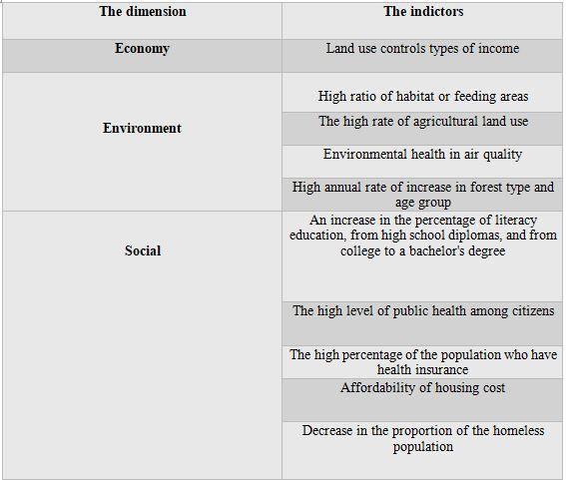

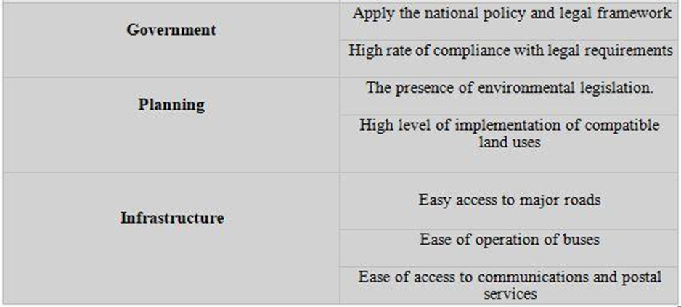

Result
When reading the results, we find that they view the community as a local audience that (1) does not barter basic future requirements for their requirements, (2) tries to address current-day issues and (3) is convinced that everyone is given the opportunity to progress within the community to a large and consistent extent with the internal environment.

Economy dimension
When reviewing the results of the evaluation by experts and the local public on the application of sustainability indicators in the economic dimension, we find that the evaluation of all indicators with the exception of one indicator does not achieve sustainability with land uses, as the first indicator was (the initial cost of land), we find that experts and the local public agreed that the initial cost of land is high. Very, and this applied to the rest of the indicators (the cost of land during the life cycle, the cost of resettlement for people, the ratio of low and medium-cost land to high-cost homes), but in the end we found that experts and the local public agreed on the value of the rise and thus the failure to achieve sustainability, and we prefer The reason for this is the poor economic situation in general in the country and in particular the city of Irbid, as it, like other developing cities, is exposed to great challenges due to the explosion of population growth and its exposure to successive migrations, all in return for a scarcity of resources, and the continuous rise in land prices often poses a threat to any economy, and has stood as enormous obstacles Facing the growth and sustainability of the economy, in addition to its main role in creating and expanding the problem of difficult housing ownership for individuals.

When looking at the results of evaluating the indicator (rehabilitating the cost of the ecosystem), we find that experts and the local public have agreed on the low cost of rehabilitating the ecosystem, and the low cost, in this case, also means the failure of the index to achieve sustainability.

If this indicates anything, it will indicate the existence of a major economic and environmental challenge facing the city of Irbid, because the rehabilitation requires a high financial and technical investment, and proper planning, all under the bad economic conditions that the city is experiencing.
The only indicator that achieved sustainability is the consensus of experts and the local public on (land use controls the types of income), as their answers were limited to applying this indicator, but with varying proportions between moderate application and strong application.

Environment dimension
When looking at the results of the evaluation of the indicators of the sustainability of land use on the environmental dimension, we find that sustainability has been achieved according to the assessment of experts and the local public in the high percentage of habitats or feeding areas, the high rate of agricultural land use and the annual increase in the type of forests, but when standing on the health index Environmental health in air quality, we find that the experts evaluated it as high environmental health in air quality, contrary to the opinion of the local public who assessed that the environmental health in air quality is very low. It is likely that the reason for the difference in evaluation is that the experts' evaluation is knowledgeable, and the subject is studied in a purely scientific manner.
On the other hand, there are eleven indicators that have not achieved sustainability, including (negative implication use of sustainable water supplies to avoid depletion of resources, lack of reserves of drinking water in excess of the proportion of the population, failure to preserve and preserve soil resources, renewal and flexibility in preserving natural resources, a high number The times vehicles pass through newly planted sites causing pollution, the recreational use section provides recreational services with less impacts on wildlife and the environment).
The poor environmental situation and the low application of sustainability indicators in the environmental dimension is closely related to the economic situation and its link to sustainability, since environmental protection and enhancement is an integral element of the transformation process towards a green economy, i.e. harmonization between the economy and the environment.

Social dimension
When analyzing the findings of the social dimension evaluation of land use sustainability indicators, we find that five of the thirteen indicators have achieved sustainability according to the assessment of experts and the local public, who unanimously agreed on the high percentage of literacy learners from high school diplomas and from college to bachelor's degrees. An increase in the level of public health among citizens, an increase in the percentage of the population who have health insurance and the ability of citizens to afford housing costs, and a decrease in the percentage of the population without shelter.
The awareness of the Jordanian people of all its social components is clearly visible and is a vital matter. The current state of awareness pushes us to push forward the state of awareness and social awareness of the political and economic situations, so that from Corona's positive repercussions, manifestations of some human cultures have emerged on one preventive behavior that is voluntarily adhered to before. Individuals and human societies, and that all bodies responsible for health prevention work in the same direction and with unparalleled cooperation between these parties. The virus worked to change behaviors and social habits rooted in Jordanian culture, which was difficult to change whatever the justifications, but within two weeks Corona created more behaviors and habits in our Jordanian society. Civilized than before, it works to protect and prevent the Jordanian person from being exposed to disease, including the abolition of the habits of kissing, hugging, shaking hands, drinking coffee with others in the same cup, using others ’tools, and paying attention to hygiene“ despite the scarcity of water in Jordan ”and sanitary sterilization of all things, and the commitment to reside and reduce Unjustified mobility, avoiding overcrowding, not transmitting pathological infection to family members or others, and not gathering during a visit Patients come in hospital, and others develop other good habits.

They differed in opinion on the rate of recorded crimes compared to the average percentage of the population. The experts agreed on the high rate of recorded crimes, and the local public unanimously agreed on the low rate of recorded crimes, and the experts ’opinion was finally approved, as the latest studies on this topic have proven, as the forensic statistical report published by the Public Security Directorate on the Criminal Information Department website proved that The rate of crimes committed in Jordan increased by 7.57% in 2019 compared to 2018 (A.-G. J. Newspaper, 2020).

Government dimension

In the government dimension, we find that the results of the indicators evaluation tended to be fair in application, so we find that two of the four indicators achieved sustainability according to the assessment of experts and the local public, who unanimously agreed that the national policy and legal framework are strongly applied in the Jordanian government, and that the rate of compliance with legal requirements Too high, but it lacks the extent of its involvement and transparency with citizens.

The Hashemite Kingdom of Jordan is going through a daunting period and multifaceted stresses, partly due to the regional and international diplomatic movement, and partly due to the persistence of current regional circumstances and the inability to find solutions to the crises surrounding Jordan, and finally, the economic conditions such as the general budget deficit, the size of debt, the low standard of living, and the high prices In addition, all factors affecting the general situation of the state.

Therefore, we find that the importance of rebuilding the internal front of the homeland, and building the internal national immunity to face internal challenges and crises and external targeting, requires serious, diligent and sincere work to find modern economic solutions to the existing problems and the search for creative practical alternatives to address various administrative, economic, social and political crises.

Planning dimension
In the planning dimension, we also find that the results of the indicators evaluation tended to be fair in application. Experts and the local public unanimously agreed on the existence of strongly enforced environmental legislation, and the level of implementation of compatible land uses is high and severe, but it lacks a rural planning for city villages, aiming at rural planning. Its origin is to move from the economic stagnation that rural areas are known in general, and this is through creating a kind of growing economic balance by bringing about change and renewal in the various rural sectors, but unfortunately despite the migration movement of the rural population towards the cities and the lack of planning after it, it does not witness No interest from the planners. Achieving sustainable economic and social growth in rural areas that are characterized by a dense population requires the adoption of a regional planning method as a basic approach to rural development. It also needs to continuously conduct studies and applied research in order to identify the nature of the prevailing conditions to find alternative formulas for planning for rural development. As such studies contribute effectively to enabling the planning authorities to identify centers and areas in which there is a shortage of services and at the same time to know the centers that do not exploit the services and economic activities in them or reduce them, and this type of analysis will lead to a series of classifications of centers that start first from the state of services In it, but later it depends on the effort required to develop these services.

Infrastructure dimension

Finally, on the infrastructure dimension, the results of the indicators evaluation showed ease of accessibility to main roads, ease of operation of buses, ease of access to communications and postal services. However, the high rate of road density and the high average distance between the current uses of the land prevented the implementation of all indicators of the infrastructure dimensions of land use, and here, despite the application of most indicators for this dimension, the city of Irbid, under the shadow of the Syrian crisis, is a stricken governorate. It suffers from a poor economic situation in it, and is in dire need to address traffic congestion, severe congestion and overcrowding as a result of the large population growth, and work to upgrade the infrastructure of the city of Irbid road network, but governments are suffering from a shortage of financial resources that requires them to fulfil these needs on their own. Therefore, to help close this divide, it is important for the private industry to play a greater role.

References

Briassoulis, H. (2001). Sustainable Development and its Indicators: Through a (Planner's) Glass Darkly. Journal of Environmental Planning and Management, 409-427.
Gallopín, G. (1995). The potential of agroecosystem health as a guiding concept for agricultural research. 1, 129-140.
Herrick, J. (2000). Soil Quality: An Indicator of Sustainable Land Management? Applied Soil Ecology, 15, 75-83. doi:10.1016/S0929-1393(00)00073-1
Koomen, A. (2021). Sustainable Land Use. Retrieved from https://www.wur.nl/en/Research-Results/Research-Institutes/Environmental-Research/Programmes/Sustainable-Land-Use.htm
Metternicht, G. (2018). Contributions of Land Use Planning to Sustainable Land Use and Management. In Land Use and Spatial Planning (pp. 35-51): SpringerBriefs in Earth Sciences.
Roy, M. (2009). Planning for sustainable urbanisation in fast growning cities:mitigation and adaptation issues addressed in Dhaka, Bangladesh. Habitat International, 276-286.
Samara, F. T., S.; Sakellariou, S.; Christopoulou, O. (2015). SUSTAINABLE INDICATORS FOR LAND USE PLANNING
EVALUATION: THE CASE OF A SMALL GREEK ISLAND Fresenius Environmental Bulletin, 24.

